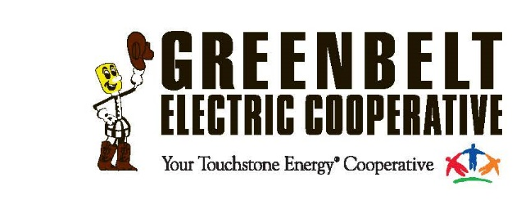
Greenbelt Electric Cooperative
Operation Round Scholarship 2024

Eligibility:
- Applicants much be a child of or under the legal guardianship of a current member of Greenbelt Electric Cooperative.
- Applicants must graduate from high school or earn a GED in the same year the scholarship is awarded.
- Scholarship recipients must meet entrance requirements and enroll in a college or trade school during the first fall semester after the scholarship is awarded. Scholarship funds will be paid directly to the appropriate institution.
- Application deadline: February 2, 2024, at 4:30 p.m.

All applications must include:
- Two letters of recommendation from teachers, counselors, coaches, community leaders, clergy, or electric cooperative directors or managers. One must be from a current teacher. Applicant’s parents are not eligible to write letters of recommendation.
- A 300-word, typewritten essay on one of the following topics:
-Why is electricity important in my life?
-How was Greenbelt Electric Cooperative formed?
-How has my electric coop impacted my community?
-What would my life be like without electricity?
- A description of volunteer involvement in school, church, or community organizations.
- A statement of goals for the future.
- A high school transcript or proof of GED score.

Application deadline is February 2, 2024, at 4:30 p.m.
Email completed and signed application to:
Janie Duncan at jduncan@gectx.coop
NOTE: Applications submitted via email must have one composite .pdf attachment containing all required materials. Incomplete applications will be considered ineligible.
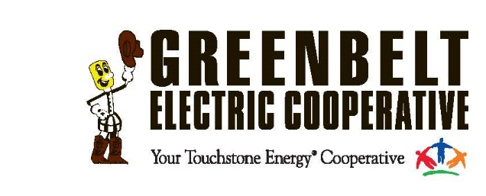
Greenbelt Electric Cooperative
Operation Round Scholarship 2024

Applicant’s Last Name ___________________________First Name ______________________
Home Address ________________________________________________________________
City, State, Zip ________________________________________________________________
Date of Birth _______________Home phone _______________Cell Phone ________________
Applicant email address _________________________________________________________
Parent email address ___________________________________________________________
Name(s) of Parent(s) or Guardian(s) ________________________________________________
Father’s Place of Employment ____________________________________________________
Mother’s Place of Employment ___________________________________________________
Name of high school ____________________________________________________________
School Address ________________________________________________________________
City, State, Zip_________________________________________________________________
Graduation date _______________________________________________________________

College or trade school you plan to attend:

A description of volunteer involvement:

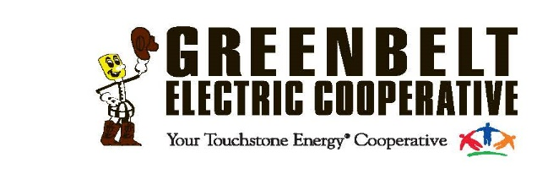
Greenbelt Electric Cooperative
Operation Round Scholarship 2024

A Statement of goals for the future:

The completed 2024 scholarship application along with two letters of recommendations and a 300-word typed essay are due by 4:30 p.m. on February 2, 2024.

Statement of Accuracy
I hereby affirm that all stated information provided by me is true and correct to the best of my knowledge. I hereby understand that if chosen as a scholarship winner, I must provide evidence of enrollment/registration at the postsecondary institution I will be attending before scholarship funds can be awarded.

Signature of Applicant Date

